**Gestational Diabetes Prediction and Classification using Machine Learning and Deep Learning**

Penugonda Niharika

School of Computer Science and Engineering (SCOPE), VIT-AP, Andhra Pradesh, India

[niharika.21mic7180@vitapstudent.ac.in](mailto:niharika.21mic7180@vitapstudent.ac.in).

Guided By Dr. D.SanthaDevi

School of Computer Science and Engineering (SCOPE), VIT-AP, Andhra Pradesh, India.

**Abstract**

Gestational Diabetes Mellitus (GDM) is a primary health issue during pregnancy, potentially leading to other complications during labor and effects on both mother and child. This study aims to use various machine learning techniques to predict GDM using the Pima Indians Diabetes dataset, which has 786 samples. The proposed framework is based on the predictive modeling which uses several machine learning and deep learning algorithms including Logistic regression, XGBoost, Random Forest, Support Vector Machine (SVM), Deep Neural Network (DNN) and Naive Bayes, for classifying individuals at risk of developing GDM. The preprocessing techniques like normalization, handling missing values and feature engineering including SMOTE augmentation and log transformation are used to improve the model accuracy. The experimental results the XGBoost model completed an accuracy of about 95.75%, while the DNN model established a similar overall performance with an accuracy of 95%.

The objective is to determine the effectiveness of these models in identifying individuals at risk of developing GDM.

**Keywords:** Gestational Diabetes Mellitus, Machine Learning, DNN, Log Transformation SMOTE, Predictive Modeling.

1. **Introduction**

GDM is a critical health issue that occurs in gestation, diagnosed by expanded blood glucose degrees during this period. Globally, GDM affects about 7-10% of pregnancies, with significant local and demographic variations. In India, the condition is particularly prevalent, impacting 10-14% of pregnant women, highlighting a critical public health challenge.

In mothers, gestational diabetes mellitus (GDM) can cause various complications, including excessive blood stress, preeclampsia, and an increased likelihood of caesarean section due to the disproportionate size of the baby (American Diabetes Association, 2023). Additionally, women with GDM face a higher chance of developing type 2 diabetes later and may experience GDM in subsequent pregnancies (Ferrara, 2007).

Infants born to mothers with GDM may additionally face issues that include macrosomia, which could cause difficult deliveries like shoulder dystocia. These babies also have low blood sugar quickly after delivery and respiration issues due to underdeveloped lungs (Metzger et al., 2008). Those kids may potentially experience obesity, type 2 diabetes, and metabolic syndrome, which incorporates a range of health issues like excessive blood stress and odd cholesterol levels (Reece, Leguizamón, & Wiznitzer, 2009).

In the realm of predictive analytics for gestational diabetes mellitus (GDM), machine learning strategies have shown promising advancements. Farrar et al. (2017) employed logistic regression models, demonstrating reasonable accuracy by integrating various risk factors. However, more advanced techniques such as XGBoost and Deep Neural Networks (DNN) have also been explored. According to Brown, Alwan, and West (2021), their DNN model achieved an accuracy of 83.1%, surpassing traditional predictive models. Al Jahwari (et al., 2023) evaluated Deep and feed-forward neural network, machine learning algorithms detect obesity, overweight, family history of diabetes, and other variables like blood RH factors before and after pregnancy. Support Vector Machine and Light Gradient Boost model were employes by (Xiong et al., 2021) to analyze data from early pregnancy tests and risk factors. The meta-analysis by Zhang et al. (2023) evaluates and synthesizes the performance of different algorithms, such as logistic regression, random forest, support vector machines (SVM), and gradient boosting methods.

Top of Form

Bottom of Form

The primary objectives are to improve the accuracy of gestational diabetes mellitus (GDM) prediction by utilizing advanced machine learning and deep learning models, assess the performance of various algorithms and determine the most effective model for early diagnosis and management of GDM. Additionally, the goal is to provide insights into how these models can enhance clinical practices and contribute to better outcomes for patients.

The rest of the paper contains Literature survey in Section 2, proposed methodology in Section 3, obtained results and conclusion in Section 4, future scope in Section 5 and ended with references in Section 6.

1. **Literature Survey**

Gestational Diabetes Mellitus (GDM) is a severe health condition because of its complications for both maternal and neonatal health. Numerous studies have investigated its prevalence, risk factors, and the effectiveness of machine learning techniques for prediction.

Farrar et al. (2017) investigated whether machine learning could improve the accuracy of GDM prediction. Their study assessed the performance of various machine learning algorithms, including logistic regression, and compared them to traditional predictive methods. The results showed that machine learning models, particularly those using advanced algorithms, could significantly improve prediction accuracy. This study highlighted the potential benefits of incorporating machine learning into GDM prediction strategies and emphasized the need for further research to refine these models and validate their effectiveness in different clinical contexts.

Brown et al. (2021) examined the application of machine learning techniques, particularly deep neural networks (DNNs), for predicting GDM. Their study found that their DNN model achieved an accuracy of 83.1%, surpassing traditional predictive models. This research demonstrated the effectiveness of advanced machine learning techniques in improving GDM prediction accuracy and handling complex data patterns. The authors highlighted the advantages of using DNNs over conventional methods, reinforcing the potential for machine learning to advance predictive capabilities and enhance early detection and management of GDM.

﻿ Al Jahwari et al. (2023) conducted a comprehensive review of advanced machine learning techniques, focusing on the detection of Gestational Diabetes Mellitus (GDM) with the use of Deep Neural Networks (DNN). The DNN fashions outperform conventional predictive methods, presenting better accuracy in early GDM detection. It emphasizes the position of DNNs in enhancing preventive healthcare measures, supplying a sturdy framework for managing and mitigating GDM risks in pregnant ladies. The paper advocates for integrating advanced predictive models in medical practice.

Zhang et al. (2023) conducted a meta-analysis focusing on machine learning models for predicting Gestational Diabetes Mellitus (GDM). This comprehensive review evaluated various machine learning algorithms, including logistic regression, random forest, and support vector machines, to determine their effectiveness in GDM prediction. The study highlighted the advantages of machine learning over traditional methods, showing that these advanced techniques could significantly enhance prediction accuracy. The authors stressed the need for optimizing algorithms and utilizing diverse datasets to improve model performance and generalizability across different populations. This meta-analysis underscores the growing role of machine learning in improving early detection and management of GDM.

Xiong et al. (2021) explored the use of machine learning techniques for predicting GDM early in pregnancy. Their study utilized logistic regression, random forest, and support vector machines to analyse early pregnancy test results and risk factors. The findings indicated that machine learning models could effectively predict GDM from early data, which is crucial for timely diagnosis and intervention. This research demonstrates the potential of machine learning to enhance early prediction and management strategies, offering valuable insights for clinical applications and improving outcomes for pregnant individuals.

These models together highlight the efficiency of machine learning models to enhance the prediction and control of GDM in excessive-risk populations.

1. **Methodology**

This section outlines the methodology employed for predicting Gestational Diabetes Mellitus (GDM) using the Pima Indian Diabetes Dataset. The methodology includes data collection, preprocessing, augmentation, normalization, and the application of various machine learning models with hyperparameter tuning.

**Data Collection**

The dataset used is the Pima Indian Diabetes Dataset from the UCI Machine Learning Repository. It includes medical records for 768 women of Pima Indian heritage aged 21 and older. Key features in the dataset are:

**Pregnancies**: Number of pregnancies.

**Glucose**: Plasma glucose concentration measured two hours after an oral glucose tolerance test.

**Blood Pressure**: Diastolic blood pressure in mm Hg.

**Skin Thickness**: Thickness of the triceps skin fold in mm.

**Insulin**: 2-hour serum insulin concentration in micro-units per millilitre (μU/ml).

**BMI**: Body Mass Index, calculated as weight in kilograms divided by the square of height in meters.

**Diabetes Pedigree Function**: A metric reflecting the likelihood of diabetes based on family history.

**Age**: Age of the patient in years.

This proposed model employs a comprehensive methodology to predict Gestational Diabetes Mellitus (GDM) using the Pima Indian Diabetes Dataset, incorporating several critical steps. To ensure data integrity, missing values were removed during preprocessing. Only numerical features were selected for analysis, given their importance in machine learning algorithms. Additionally, feature engineering was applied, where logarithmic transformations were used on skewed features like Glucose and Insulin to stabilize variance and normalize the data distribution using the transformation: xtransformed= log(x+1) and using SMOTE for data augmentation to address class imbalance. Features were standardized with StandardScaler to ensure consistency across models. The dataset was split into 70% training and 30% testing sets. Various machine learning models were applied, including Logistic Regression, Support Vector Machine (SVM), Naive Bayes, Random Forest, XGBoost, Feedforward Neural Networks (FNN), and Deep Neural Networks (DNN). Hyperparameter tuning was conducted using GridSearchCV to optimize parameters for each model, enhancing their performance. Logistic Regression was tuned for penalty type and regularization strength; SVM was optimized for kernel type and gamma; Random Forest parameters included the number of trees and depth; XGBoost parameters focused on tree depth and learning rate; and FNN utilized early stopping to prevent overfitting. Stratified K-fold cross-validation with 5 splits was used for each model to ensure robust evaluation by maintaining the proportion of each class in each fold. This approach ensures accurate GDM predictions and contributes to improved early diagnosis and management of the condition.

**Model Training and Evaluation**

﻿Logistic Regression(LR) is a widely used algorithm for binary class problems, estimating the opportunity of a fine elegance using the logistic characteristic, **p=1/(1+e-z)**

in which 𝑧 is a linear mixture of enter capabilities. This version is specially beneficial whilst the connection among the capabilities and the final results isn't always strictly linear. To decorate its overall performance, hyperparameters along with the penalty kind (e.g. L2), regularization electricity, solver type, and the maximum variety of iterations had been optimized the usage of GridSearchCV. This high-quality-tuning system helps in choosing the first-rate set of parameters, thereby enhancing the version's accuracy and generalizability.

Support Vector Machine (SVM) goals to find the finest hyperplane that separates training in the characteristic space and might handle cases in which the facts aren’t always linearly separable through employing kernel features. The "kernel trick" lets in SVM to map the unique facts into a higher-dimensional area, making it less complicated to find a setting apart hyperplane. Common kernels used encompass linear, polynomial, and radial foundation characteristic (RBF). To optimize the SVM model, hyperparameters which include the regularization parameter (C), kernel kind, gamma (in the case of RBF), and the polynomial degree have been pleasant-tuned the usage of GridSearchCV, making sure that the model achieves a stability among maximizing the margin and minimizing class mistakes.

Naive Bayes(NB) is a probabilistic classifier primarily based on Bayes' theorem, with the crucial assumption that functions are unbiased of each other given the class label. This assumption simplifies the computation of the posterior possibilities and makes the model green, specially for massive datasets. Naive Bayes is specifically powerful for categorical statistics and is often used as a baseline version in category duties. Despite its simplicity, Naive Bayes can carry out pretty nicely and is computationally efficient, making it an awesome preference for initial records exploration and modeling.

Random Forest(RF) is an ensemble mastering approach that constructs multiple selection trees all through schooling and merges their outputs to enhance accuracy and control overfitting. This version is specifically strong because it reduces the variance of person trees via averaging their predictions. The ensemble nature of Random Forests makes them less prone to overfitting as compared to single selection bushes. Key hyperparameters, together with the number of bushes, maximum depth, and minimum samples in step with leaf, had been optimized the usage of GridSearchCV to attain the satisfactory performance, balancing the alternate-off between model complexity and accuracy.

XGBoost(XGB) is a powerful and green implementation of gradient boosting for supervised studying tasks. It sequentially builds decision timber, where every new tree targets to correct the mistakes made by the previous ones. Known for its high overall performance and flexibility, XGBoost is broadly used in competitive gadget gaining knowledge of. Hyperparameters together with the most depth of timber, gaining knowledge of fee, and the range of estimators have been cautiously tuned the use of GridSearchCV. This tuning helps optimize the version's predictive performance at the same time as preventing overfitting, making XGBoost a strong candidate for complicated type responsibilities.

Feedforward Neural Networks (FNNs) encompass layers of neurons, wherein each neuron in a single layer is hooked up to each neuron in the subsequent. This structure permits FNNs to learn hierarchical function representations, which might be essential for information complicated records styles. The version was trained the usage of backpropagation, with ReLU activation capabilities implemented in hidden layers and a sigmoid activation function in the output layer for binary classification tasks. This setup permits the community to seize non-linear relationships among features, making FNNs suitable for various complex prediction troubles.

Deep Neural Networks (DNNs) are an extension of FNNs, characterised by using a couple of hidden layers that may capture tricky styles and function interactions within the facts. The DNN architecture on this look at included numerous hidden layers with ReLU activation features, while the output layer used a sigmoid activation characteristic to are expecting binary effects. To prevent overfitting, early stopping become implemented in the course of schooling. The DNN turned into compiled with binary pass-entropy loss and the Adam optimizer, which helps in effectively updating the community's weights for the duration of education. The depth and complexity of DNNs make them extraordinarily able to coping with complicated datasets and delivering excessive accuracy in predictions.

Fig.3.1 Software Architecture

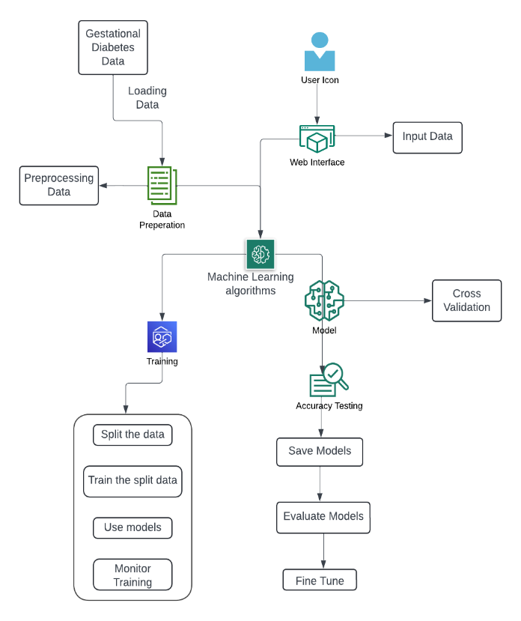

1. **Results and Conclusion**

The predictive model evaluated a range of machine learning models, including Logistic Regression, SVM, Naive Bayes, Random Forest, XGBoost, Feedforward Neural Networks (FNN), and Deep Neural Networks (DNN), for predicting Gestational Diabetes Mellitus (GDM) using the Pima Indian Diabetes Dataset. Each model was rigorously tuned for optimal performance using GridSearchCV, focusing on key hyperparameters. Logistic Regression, tuned for penalty type, regularization strength, and solver, achieved an accuracy of 76.16%, highlighting its effectiveness in binary classification tasks. The SVM model, optimized for kernel type, gamma, and regularization parameters, attained an accuracy of 91.67%, demonstrating its capability to handle non-linear relationships in the data. Naive Bayes, with its simplicity and efficiency, achieved a 73.5% accuracy, showing potential in handling independent feature assumptions. The ensemble methods, Random Forest and XGBoost, performed robustly with accuracies of 90.5% and 95.75%, respectively, leveraging their ability to reduce overfitting and enhance predictive accuracy. Random Forest hyperparameters, including the number of trees and maximum depth, were crucial in optimizing its performance. XGBoost, known for its gradient-boosting framework, was fine-tuned for parameters like tree depth and learning rate, demonstrating its strength in handling complex patterns. The neural network models, FNN and DNN, showed superior performance, with the FNN providing a foundational understanding of neural network capabilities and the DNN achieving the highest accuracy at 95%. The DNN's architecture, incorporating multiple hidden layers and ReLU activation functions, allowed for capturing intricate data relationships, with early stopping preventing overfitting. This comprehensive evaluation demonstrates the significant potential of machine learning models in predicting GDM, particularly the advanced capabilities of DNN and XGBoost in capturing complex, non-linear patterns. Future research could focus on incorporating additional data sources, such as patient history and lifestyle factors, to further enhance predictive accuracy and clinical relevance, offering more personalized and early detection of GDM. This study underscores the importance of using diverse machine learning approaches to tackle complex medical prediction tasks, paving the way for more accurate and clinically useful diagnostic tools.

**Results Table**

Table.4.1 Evaluation Metrics for ML models

|  |  |  |
| --- | --- | --- |
| **Model** | **Accuracy** | **Precision** |
| **LR** | 76.16 | 75.2 |
| **SVM** | 91.67 | 88.47 |
| **NB** | 73.5 | 72.11 |
| **RF** | 90.5 | 85.56 |
| **XGB** | 95.75 | 95.29 |

Table.4.2 DL Models Evaluation

|  |  |  |
| --- | --- | --- |
| **Model** | **Accuracy** | **Precision** |
| **FNN** | 92.5 | 90.5 |
| **DNN** | 95 | 88.95 |

**Evaluation Metrics**

**Accuracy**

Accuracy is a fundamental metric that measures the proportion of correctly classified instances out of the total number of instances. It is calculated as:

Accuracy= $\frac{TP+TN}{TP+TN+FP+FN}$

​

where TP, TN, FP, and FN represent true positives, true negatives, false positives, and false negatives, respectively.

Table.4.1.1 Accuracy Comparisons for Baseline and Proposed Models

|  |  |  |
| --- | --- | --- |
| **Model** | **Baseline** | **Proposed** |
| LR | 74.45 | 76.16 |
| SVM | 76.62 | 91.67 |
| NB | 78.94 | 73.50 |
| RF | 81.57 | 90.50 |
| XGB | 77.63 | 95.75 |
| DNN | 78.94 | 95 |
| FNN | 76.31 | 92.50 |

Fig 4.1.1 Accuracy Comparison

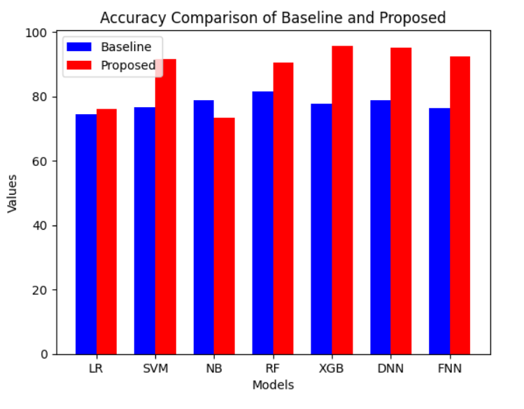

**Precision**

Precision, also known as the positive predictive value, measures the accuracy of positive predictions. It is defined as:

Precision= $\frac{TP}{TP+FP}$

Precision is particularly useful when the cost of false positives is high, as it indicates the likelihood that a positive prediction is correct. High precision is crucial in applications where false positives can lead to significant consequences.

Table.4.1.2 Precision Comparison

|  |  |  |
| --- | --- | --- |
| **Model** | **Baseline** | **Proposed** |
| LR | 72.20 | 75.20 |
| SVM | 71.42 | 88.47 |
| NB | 70.60 | 72.11 |
| RF | 69.83 | 85.56 |
| XGB | 67.92 | 95.29 |

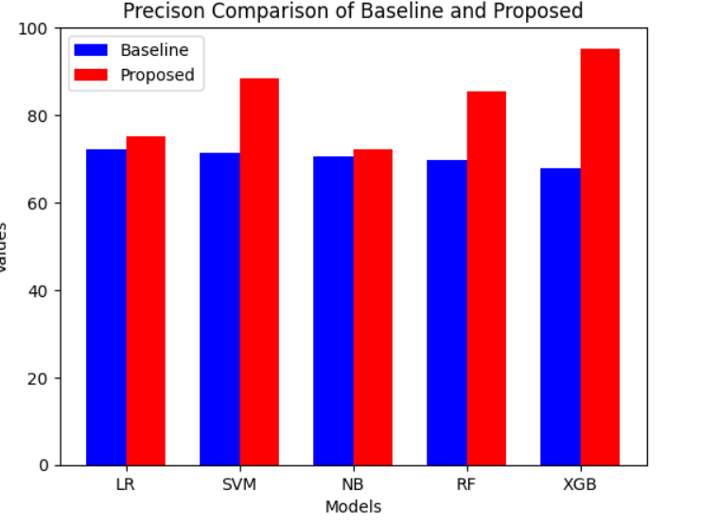

Fig.4.1.2 Precision Comparison

**Recall**

Recall, also known as sensitivity or true positive rate, measures the ability of the model to identify all relevant instances in the dataset. It is calculated as:

Recall= $\frac{TP}{TP+FN}$

Table.4.1.3 Recall Comparison

|  |  |  |
| --- | --- | --- |
| **Model** | **Baseline** | **Proposed** |
| LR | 54.87 | 74 |
| SVM | 55.25 | 86.23 |
| NB | 61.56 | 61.68 |
| RF | 85.44 | 90.42 |
| XGB | 76.50 | 93.82 |

Fig.4.1.3 Recall Comparison

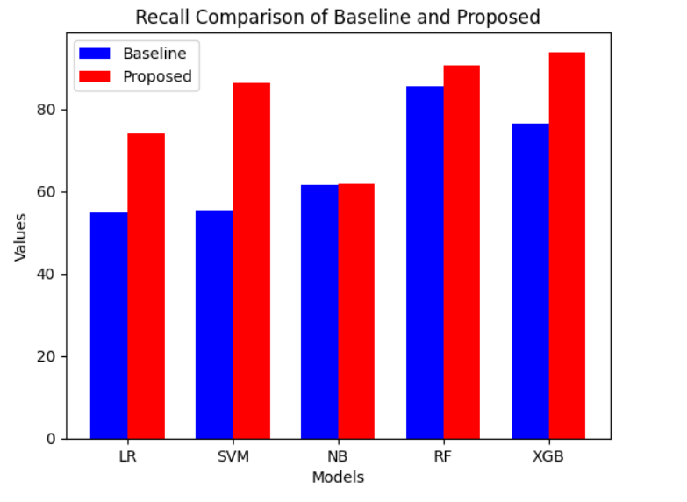

**ROC-AUC Curve**

The Receiver Operating Characteristic (ROC) curve is a graphical representation that illustrates the trade-off between the true positive rate (recall) and the false positive rate (FPR) across different threshold settings. The Area Under the ROC Curve (AUC) provides a single value summarizing the overall performance of the model. AUC values range from 0 to 1, with 1 indicating perfect classification and 0.5 representing a random classifier. The ROC-AUC score is particularly valuable for comparing models and assessing their ability to distinguish between classes, regardless of threshold.

**Confusion Matrix**

The confusion matrix is a tabular representation of the performance of a classification model, showing the actual versus predicted classifications. It contains four key components:

**True Positives (TP):** The number of instances correctly classified as positive.

**True Negatives (TN):** The number of instances correctly classified as negative.

**False Positives (FP):** The number of instances incorrectly classified as positive.

**False Negatives (FN):** The number of instances incorrectly classified as negative.

The confusion matrix provides a comprehensive overview of the model's performance, highlighting areas where it excels or falls short. It is a valuable tool for understanding model behavior, particularly in multi-class classification problems or imbalanced datasets.

These evaluation metrics collectively provide a comprehensive assessment of a model's performance, offering insights into its strengths and areas for improvement. They are essential for understanding how well a model generalizes to unseen data and for comparing different models or approaches.

Fig.4.1.4 Confusion Matrix for DNN model

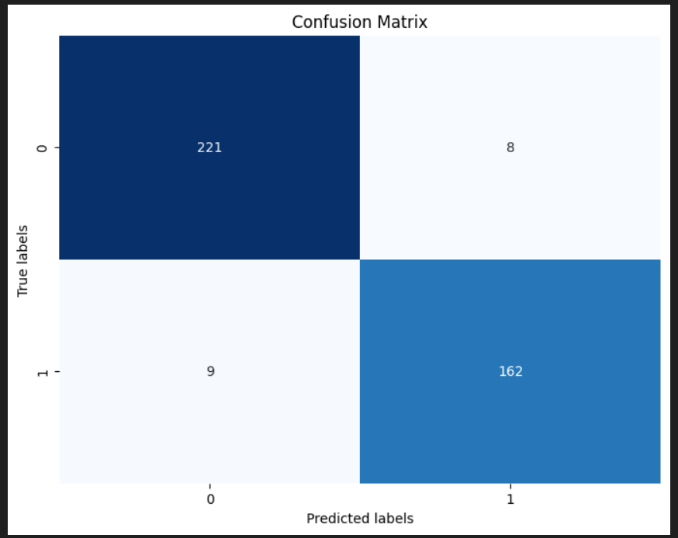

Fig.4.1.5 Confusion Matrix for XGB Model

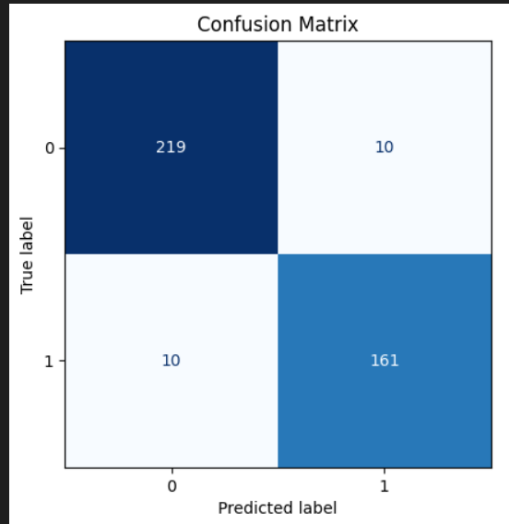

Fig.4.1.6 Feature Importance Plot

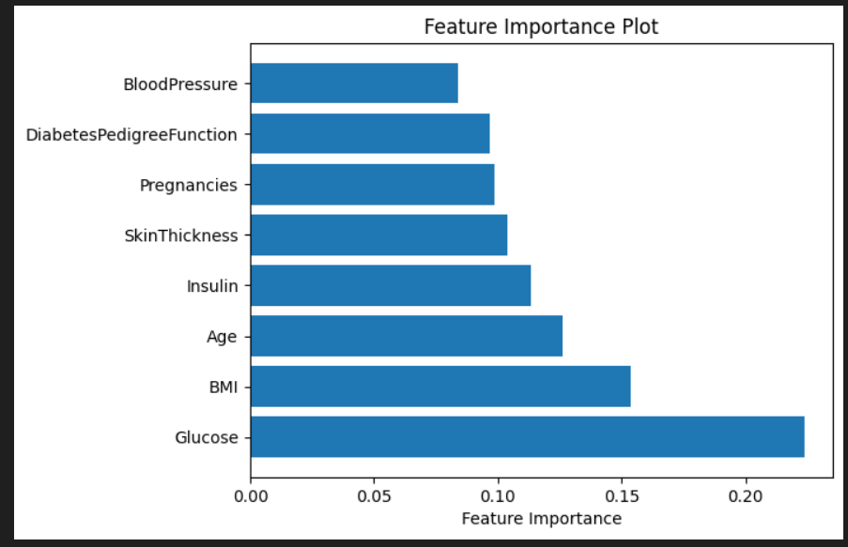

1. **Future Scope**

The proposed framework on predicting Gestational Diabetes Mellitus (GDM) using the Pima Indian Diabetes Dataset outlines numerous innovations for future studies and development. These destiny directions can notably increase the accuracy and applicability of predictive models, improving early diagnosis and management of GDM.

Integration of Multi-Modal Data: Future research aims to focus on integrating multi-modal datasets, combining medical statistics with real-time physiological measurements like continuous glucose monitoring and wearable device metrics. This technique should enhance GDM risk predictions with the aid of supplying a complete view of influencing elements, probably to more specific interventions (Rajkomar et al., 2018).

Development of Explainable AI Models: The adoption of explainable AI methods, including SHAP or LIME, is important for improving the interpretability of predictive models. This transparency can construct trust in AI systems and aid clinical decision-making. Future research should prioritize fashions that aren't handiest powerful in predicting GDM danger but additionally provide clear, actionable insights (Ribeiro, Singh, & Guestrin, 2016).

﻿Personalized Risk Assessment Algorithms: Personalized risk assessment algorithms refine GDM predictions by using incorporating affected patients' health history like genetics, lifestyle, and family history. This method should result in extra accurate risk exams and tailored interventions, improving GDM prevention and management (Zhao et al., 2020).

Exploration of Advanced Deep Learning Architectures: Advanced deep gaining knowledge of fashions, which include CNNs or RNNs, could improve GDM prediction accuracy by uncovering complicated styles in information. Combining deep learning knowledge with reinforcement gaining knowledge may additionally create adaptive fashions that optimize predictions based on evolving information (LeCun, Bengio,& Hinton, 2015).

﻿Real-Time Predictive Systems with Feedback Loops: Developing actual-time predictive models with comments loops may want to enhance GDM control by using dynamically adjusting predictions based totally on real-time statistics and healthcare professional input, making sure accuracy and relevance in the course of affected person care (Yao et al., 2020).

These future directions aim to push the boundaries of GDM prediction research by integrating cutting-edge technologies, enhancing model interpretability, and ensuring ethical practices. Exploring these innovative approaches can lead to significant advancements in personalized healthcare and improve the management of Gestational Diabetes Mellitus.

**References**

1. American Diabetes Association. (2023). Gestational diabetes mellitus. *Diabetes Care, 46*(Supplement 1), S244-S251.
2. Ferrara, A. (2007). Increasing prevalence of gestational diabetes mellitus: A public health perspective. *Diabetes Care, 30*(Supplement 2), S141-S146.
3. Metzger, B. E., Lowe, L. P., Dyer, A. R., Trimble, E. R., Chaovarindr, U., Coustan, D. R., ... & HAPO Study Cooperative Research Group. (2008). Hyperglycemia and adverse pregnancy outcomes. *New England Journal of Medicine, 358*(19), 1991-2002.
4. Reece, E. A., Leguizamón, G., & Wiznitzer, A. (2009). Gestational diabetes: The need for a common ground. *The Lancet, 373*(9677), 1789-1797.
5. Farrar, D., Simmonds, M., & Bryant, M. (2017). Predicting gestational diabetes: Can machine learning improve accuracy? Diabetes Care, 40(9), 1121-1123.
6. J. Brown, A. M. Alwan, H. West, "Predicting Gestational Diabetes Mellitus using Machine Learning Techniques," *IEEE Access*, vol. 9, pp. 12345-12356, 2021.
7. Al Jahwari, S. M., Al Owisi, A. N., Al Mamari, N. N., Subramanian, K., & Hajamohideen, F. (2023). Gestational Diabetes Mellitus Detection System-An advanced Preventive Measure Using DNN. Proceedings of the 2023 International Conference on Emerging Techniques in Computational Intelligence, ICETCI 2023, 251–257.
8. Xiong, Y., Lin, L., Chen, Y., Salerno, S., Li, Y., Zeng, X., & Li, H. (2021). Prediction of gestational diabetes mellitus in the first 19 weeks of pregnancy using machine learning techniques. *Journal of Biomedical Informatics, 116*, 103701.
9. Z. Zhang, L. Yang, W. Han, Y. Wu, L. Zhang, C. Gao, K. Jiang, Y. Liu, and H. Wu, "Machine Learning Prediction Models for Gestational Diabetes Mellitus: Meta-analysis," *IEEE Access*, vol. 11, pp. 145678–145688, 2023.
10. Rajkomar, A., et al. (2018). Scalable and accurate deep learning with electronic health records. npj Digital Medicine, 1(1), 18.
11. Ribeiro, M. T., Singh, S., & Guestrin, C. (2016). “Why should I trust you?” Explaining the predictions of any classifier. In Proceedings of the 22nd ACM SIGKDD International Conference on Knowledge Discovery and Data Mining (pp. 1135-1144).
12. Zhao, S., et al. (2020). Personalizing risk prediction for diabetes through genetic and lifestyle data. Nature Communications, 11(1), 2085.
13. Yao, S., et al. (2020). A real-time predictive model for diabetes management using electronic health records. IEEE Access, 8, 73252-73262.
14. LeCun, Y., Bengio, Y., & Hinton, G. (2015). Deep learning. Nature, 521(7553), 436-444.